## [**https://medium.com/agileinsider/how-to-set-up-a-bottoms-up-saas-product-analytics-stack-804451896308**](https://medium.com/agileinsider/how-to-set-up-a-bottoms-up-saas-product-analytics-stack-804451896308)

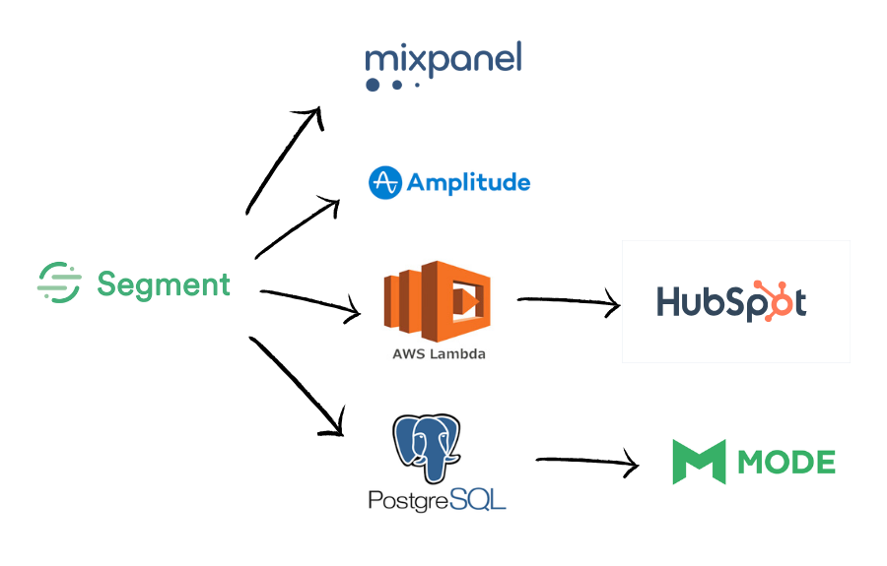

# **The bottoms-up SaaS product analytics stack**

The bottoms-up SaaS product analytics stack we’re using is:

* [**Segment**](https://segment.com/), so we can easily pipe analytics events wherever we want without troubling our engineers.
* [**Mixpanel**](https://mixpanel.com/) for a platform to understand usage.
* [**HubSpot**](https://www.hubspot.com/): In an analytics context, HubSpot is helping us visualize customer success.
* [**AWS Lambda**](https://aws.amazon.com/lambda/)with custom code converts analytics events into companies in HubSpot, so we can track customer success.
* [**PostgreSQL**](https://www.postgresql.org/) is our data warehouse, so we can run custom queries that cut across our application’s data, marketing tools and analytics events from Segment.
* [**Mode Analytics**](https://mode.com/) to run ad-hoc queries across all our data.
* [**Amplitude**](https://amplitude.com/): We’re trying out Amplitude as an alternative to Mixpanel, as we aren’t happy with Mixpanel’s ability to give analytics by each company/team using the product.

## [**https://rubenugarte.com/web-analytics-tools/**](https://rubenugarte.com/web-analytics-tools/)

## **The 5 Stages of Your Analytics Strategy**

Every company will go through the 5 stages below though some will do it faster than others. These stages are meant as guidelines to help you understand what tools to choose and how much to invest in them.

### **Stage 1: All About Product/Market Fit**

In this stage, you’re still trying to figure out the product/market fit and you’re spending nearly all your time trying to understand your users and how to improve your product. You don’t have a lot of data so you need to rely heavily on qualitative data at this stage.

You should also consider using something like the [Net Promoter Score](https://rubenugarte.com/nps-score-does-this-metric-live-up-to-the-hype/) which is a tool that can help you measure customer satisfaction.

**Recommended Tools:**

1. **Marketing Attribution**: Google Analytics to give you some basic numbers around how your website is performing. Make sure [to use the Goals functionality within Google Analytics](https://support.google.com/analytics/answer/1012040?hl=en) to track key actions such as signing up for a waitlist or for your product.
2. **Technical Diagnostic**: You’re primarily interested in features like live chat so you’re able to start engaging with visitors who come to your website.
3. **User Behavior**: Mixpanel/Amplitude and track 1-2 key actions within your product. You won’t have a lot of data so simply focus on understanding trends.

**Benchmarks to next stage:** You’re starting to spend significant money on marketing/advertising and you have enough regular usage within your product that you are collecting statistically significant data.

**Related:** If you’re in charge of marketing or product at your company, be sure to check out the [6 Reports That You Should Be Running](https://rubenugarte.com/6-analytics-reports-product-marketing-manager-running/) to increase the growth of your product and company.

### **Stage 2: Spending Significant Money on Marketing**

In this stage, you’re starting to move past product/market fit and you might be heading down a funding round or simply looking to grow. As you start to spend significant money on marketing, you can start to deploy analytics tools to help you optimize your paid traffic.

Most of your data will live within silos which shouldn’t be a huge issue but if you need to do any complex analysis of multiple tools, Excel will be your friend. It will be tedious but it will help you avoid adding a reporting tool until you actually need it.

**Recommended Tools:**

1. **Marketing Attribution**: Google Analytics will be your main tool for measuring your marketing efforts. You can add CrazyEgg for better heatmap tracking, [A/B testing once you have enough traffic](http://conversionxl.com/stopping-ab-tests-how-many-conversions-do-i-need/) and Mailchimp to collect emails. If you’re doing mobile advertising, an [attribution tool like Kochava](https://rubenugarte.com/mobile-attribution/) will help run campaigns on CPI (Cost Per Install).
2. **User Behavior**: Mixpanel/Amplitude and you can add more metrics to your initial metrics from stage 1.
3. **Technical Diagnostic**: Chat tool like Intercom to keep receiving qualitative data and you can add tools like Pingdom to help track down technical errors that could be affecting your conversion rates.
4. **Customer Support**: You can consider adding something like Intercom to communicate with customers once they are inside your product or something like Zendesk to handle customer questions.
5. **Tag Managers**: Spend some time understanding the different wrappers to set up a solid foundation on which you could new tools in the future. Make sure to figure this category out before integrating too many tools or else your transition to a wrapper will be painful.

**Benchmarks to next stage**: You have enough traffic to see where your funnels are breaking and you have some ideas such as drip emails and A/B testing to fix them. You also need to see data from multiple tools in one single dashboard which means you need some kind of reporting tool.

## [**https://rubenugarte.com/saas-analytics/**](https://rubenugarte.com/saas-analytics/)

## **Ruben’s Favorite SaaS Tools**

I get asked all the time about my favorite tools across the categories listed above. I personally like tools that can do multiple jobs since this avoids the issue of having to implement and maintain too many tools.

* **Marketing Attribution:**[Google Analytics for web](https://analytics.google.com/analytics/web/) and [Appsflyer for mobile](https://www.appsflyer.com/)
* **Product and User Behavior:**[Amplitude](https://amplitude.com/)
* **Engage Users:**[Mixpanel](https://mixpanel.com/)
* **A/B Testing:**[Optimizely](https://www.optimizely.com/)
* **User Experience & Qualitative Data:**[Hotjar](https://www.hotjar.com/)
* **Revenue Analysis:**[ProfitWell](https://www.profitwell.com/)
* **Dashboards and Reporting:**[Databox](https://databox.com/)
* **Customer Data Platforms:**[Segment.com](https://segment.com/)

## **Startup Stack (and How it Compares to Returnly)**

If you’re starting from scratch, it can be helpful to think about your entire analytics stack and not just individual tools.

This is the stack that I would recommend to a startup which is just getting started with data and doesn’t have a lot of internal resources to implement tools.

* [**Segment.com**](https://segment.com/): this will let you easily send your data to different integrations.
* [**Google Analytics**](https://analytics.google.com/analytics/web/)**/**[**Appsflyer**](https://www.appsflyer.com/): this will give critical marketing attribution data.
* [**Heap Analytics**](https://heapanalytics.com/)**:** Heap can automatically collect data from your app and let you analyze what is going on with your product.
* [**Hotjar**](https://www.hotjar.com/): collect qualitative data such as heatmaps and session recordings.
* [**Databox**](https://databox.com/)**:** quickly create dashboards of all your existing data.

I also thought it would be interested to see how this stack compares to an existing company. In this case, I chose a company called [Returnly](https://returnly.com/) which fits my criteria of “startup”.

* [Google Analytics](https://analytics.google.com/analytics/web/) (marketing attribution)
* [Google Tag Manager](https://marketingplatform.google.com/about/tag-manager/) (easily deploy tags in the site)
* [CrazyEgg](https://www.crazyegg.com/) (heatmaps)
* [Mixpanel](https://mixpanel.com/) (instead of Heap)

## <https://www.projectbi.net/ultimate-analytics-stack-startups-2020/>

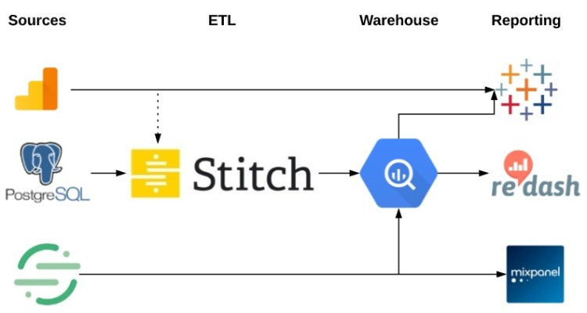

## <https://www.wunderkindagency.com/post/saas-martech-stack>

# **The Perfect Marketing Technology Stack for Your SaaS Startup in 2020**

1. Website Analytics - GA
2. CRM - Pipedrive
3. Marketing Automation - Autopilot | Active Campaign | Encharge.io and userlist.com for SaaS
4. Product Analytics - Mixpanel
5. Revenue Analytics - ChartMogul
6. Data Pipeline - Zapier | PieSync | GTM